# C:\TestProjects\Quintity\Quintity.TestFramework\Quintity.TestFramework - Trunk\Quintity.Repository\Images\QuintityLogo.jpg

The Quintity TestFramework

Getting Started Guide

Table of Contents

1

Introduction 3

Creating an automated test 3

1. Install the Quintity TestFramework 3

2. Building a test assembly 3

3. Configuring project properties for use with the TestEngineer 4

4. Creating a test suite 5

4. Adding a test case 6

5. Adding a test step 6

5. Executing the test suite 7

6. What’s next? 8

Key Concepts 8

• The Quintity Test Framework 8

• The Test Project 8

• The Test Class 9

• The Test Method 9

• Elements of a Test Method 9

• Test Properties 10

# Introduction

The purpose of this “Getting Started Guide” is to provide some working familiarity to testers and automation engineers’ of the Quintity TestFramework, its components and the mechanics of writing test automation using it. It is not an in depth user’s guide of the framework, its toolset or object mode.

This document assumes the reader has a working knowledge of software testing, its terminology and structures. Additionally, for those writing test methods, a working knowledge of Visual Studio (2010 or 2012) and a Microsoft .NET compliant language is required (Note: all subsequent examples are in C#).

# Creating an automated test

## Install the Quintity TestFramework

To setup your Quintity TestFramework, perform the following steps:

* 1. Select the Quintity.TestEngineer.Setup.msi program. Right click and select “Install”. Alternatively, double-click the *.msi.
  2. The initial installer dialog will appear, press the “Next >” button to continue to proceed to the install folder selection dialog.
  3. Enter or browse to the target installation folder. *Recommended that you use the suggested default folder*. Press “Next >” to proceed to the final confirmation dialog.
  4. Press “Next >” to confirm installation, “Cancel” otherwise.
  5. The installer will proceed to setup the Quintity TestFramework. Note: If you have Visual Studio 2012 or 2013, the installer requires several minutes to install and update the respective development environments (i.e., the installer is not “hung”).
  6. Upon successful installation, the final screen is displayed. Click “Close” to exit the application.

## Building a test assembly

* 1. Creating a QTF test assembly project is very similar to creating any other project within Visual Studio. Test project and item templates have been added to the development environment to facilitate development. To create the test assembly:
  2. Launch Visual Studio 2010 or 2012.
  3. Navigate to Visual Studio’s main menu and select “File > New > Project…” and the “New Project” dialog will appear.
  4. In the “New Project” dialog’s left pane, open the “Installed > Templates > Visual C#” selections.
  5. Select the “Quintity” item under “Visual C#” and in the center pane, you will see two project types:
     1. Basic Test Project for creating a Quintity test project.
     2. Test Listener Project for creating Quintity runtime execution listener.
  6. Select the “Basic Test Project” template.
  7. Complete the balance of the dialog fields accordingly (e.g., “Name”, “Location” and “Solution name”, “Add to source control”, etc.) and press “OK”.
  8. To check for correct project construction, build the solution or project within Visual Studio. The build should succeed without issue.

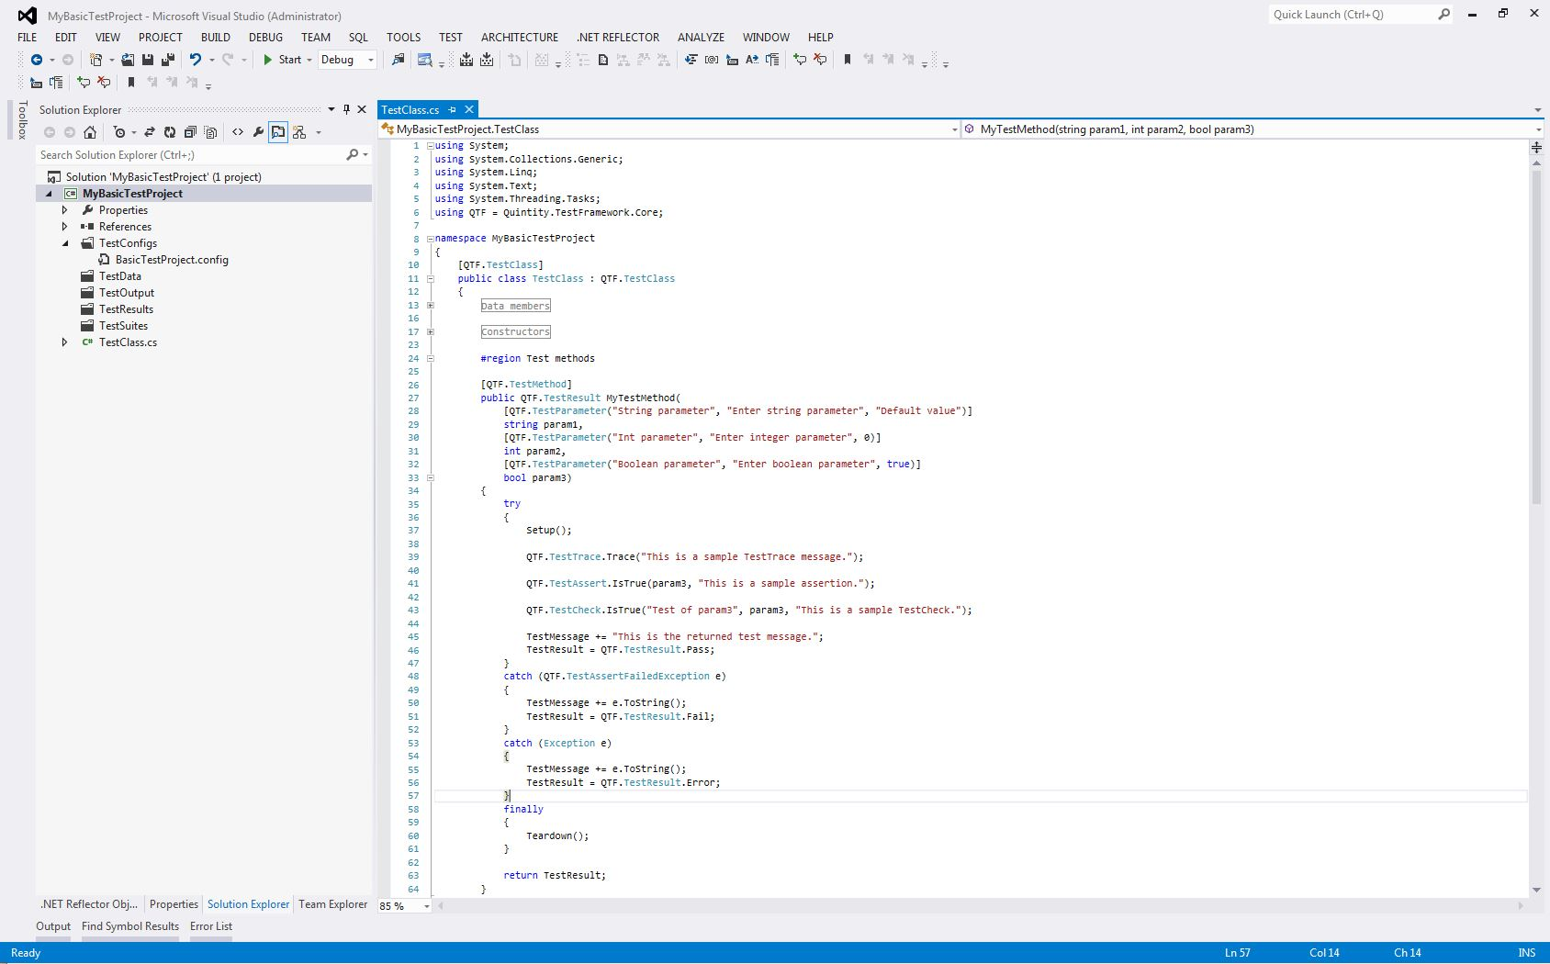

*An example of a new created test project*

## Configuring project properties for use with the TestEngineer

* 1. Once the test project is successfully created, its properties must be updated to incorporate the Quintity TestEngineer as its driver. Update the test project with these following steps.
     1. Change the test configuration file to point to the current environment.
        1. The projects default configuration file is located in the projects “TestConfigs” folder. The default name is “BasicTestProject.config”; this can be changed to something more meaningful to the user.
        2. Open the configuration file and locate the “<TestHome>c:\MySolutionPath</TestHome>“entry and change the path to the current solution’s folder. Updating this entry provides the TestEngineer and the Quintity runtime engine the necessary navigational information to locate test artifacts (e.g., test suites, test assemblies, etc.). This avoids having “hardcoded” paths in the test code.

Example: “<TestHome>C:\MyTestProjects\MyBasicTestProject</TestHome>“

* + 1. Configuring the test project’s properties.
       1. In Visual Studio, select the newly created test project, right click and select the popup menu item “Properties”. The project properties window will be displayed in the Visual Studio workspace.
       2. In the property window, select the “Debug” tab.
       3. In the “Start Action” section, select the “Start external program” option. Enter the path or browse to the installed “Quintity.TestFramework.TestEngineer.exe”
       4. In the “Start Options” edit box, add a command-line entry pointing to the projects test configuration file in the following format: “/c=“*C:\PathToYourTestProjectsConfigurationFile.config*”

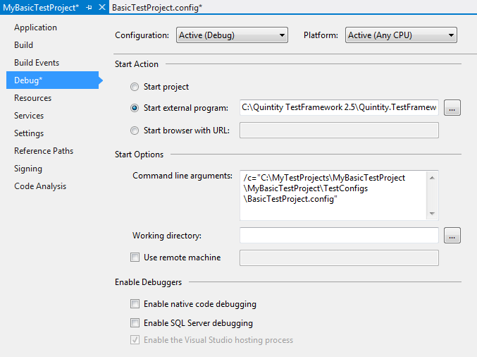

*An example of completed Test Project properties*

* 1. To verify the configuration, select and start a new instance of the test project. The Quintity TestEngineer application should come up without error and display the name of the configuration file in the lower left corner of the status bar (*Hint: hover the mouse over the name and the full path will be displayed*).

## Creating a test suite

In order to drive the project test methods, a fully formed test suite will need to be created. The test suite provides the data and linkage information to drive the test library’s test code. To create a linked test suite, do the following:

1. Launch an instance of the TestEngineer as described above.
2. Select “File > New” or click on the “New” toolbar button. A “Save As” dialog should appear with the Explorer path set to the projects “TestSuites” folder (If not, the configuration file may not have correct pathing information).
3. Enter the name of the new test suite in the “File name:” textbox. Note the default “Save as type” setting is with the “*.ste” extension. Save the new suite. The dialog will close and the newly named suite will appear in the TestEngineer’s suite viewer pane.

### Adding a test case

To be operational, each suite must contain at least one test case which must, in turn, contain at least one test step.

* 1. To add a test case, select the target test suite in the test suite viewer, right click and choose “Add New Test Case” from the popup menu. A test case is automatically added to the test suite. To change its name, select the test case and either press F2 to rename or double-click to bring the test case editor dialog.

### Adding a test step

* 1. A test step joins the test logic to the underlying test code (contained in the test class’s test methods). The test step is setup up to call the test method and to provide the necessary runtime arguments. To add a test step, select the target test case and choose “Add New Test Step” from the popup menu. A new untitled test step is added to the test case.
  2. At this point, now automation has been associated with the test step. The test step still needs to be configured for automation (it is a manual step).
  3. Double click on the test step or right mouse click and select “Open” and the test step editor dialog appears.
  4. Check the “Automation” checkbox in the lower left corner of the dialog. A “Test Method” tab has been added to the dialog and selected. Here we need to associate the test code to the test step.
  5. Test Assembly – Browse to the projects test assembly (click the Browse button). Select the project’s test assembly. If the project library is not in the dropdown selection, the project configuration may not be configured properly.
  6. Test Class – Once a test assembly has been selected, the “Test Class” dropdown is loaded with available test classes (the test classes attribute is set to “QTF.TestClass”). Select the desired test class.
  7. Test Method – Once the test class has been selected, the “Test Method” dropdown is populated with all available test methods (The test methods attribute is set to “QTF.TestMethod” and its signature is correct). Select the desired test method.
  8. Parameters – If the test method selected accepts arguments, the parameters grid will populate with each parameter’s name, its data type and default values. Change the values as desired. Note, the values can be changed and the test method can be reused to support easy generation of additional test cases.

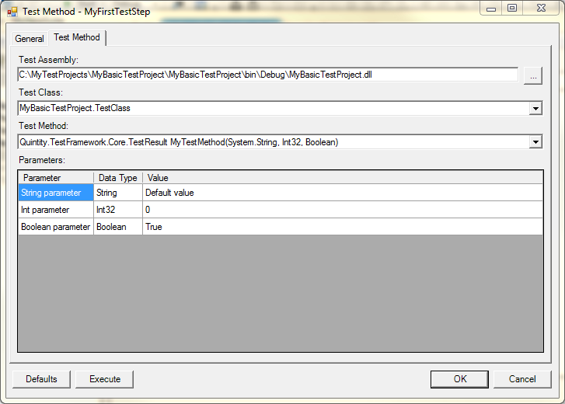

*An example of a completed automated test step*

1. Upon completion, press the dialog’s “OK” button and the test step has been updated. To complete the process, select the automated test step and change its “Test Status” in the TestEngineer’s property pane to “Active”.

## Executing the test suite

Using the setup described above, a user merely selects the test project and initiates a debug session. The TestEngineer will display. Within the TestEngineer, open the desired test suite and press “Execute” on the toolbar.

A note about debugging: if a breakpoint has been set in the test method or in subsequent code, execution will stop at the breakpoint. There is nothing inherently different in debugging source code in this scenario.

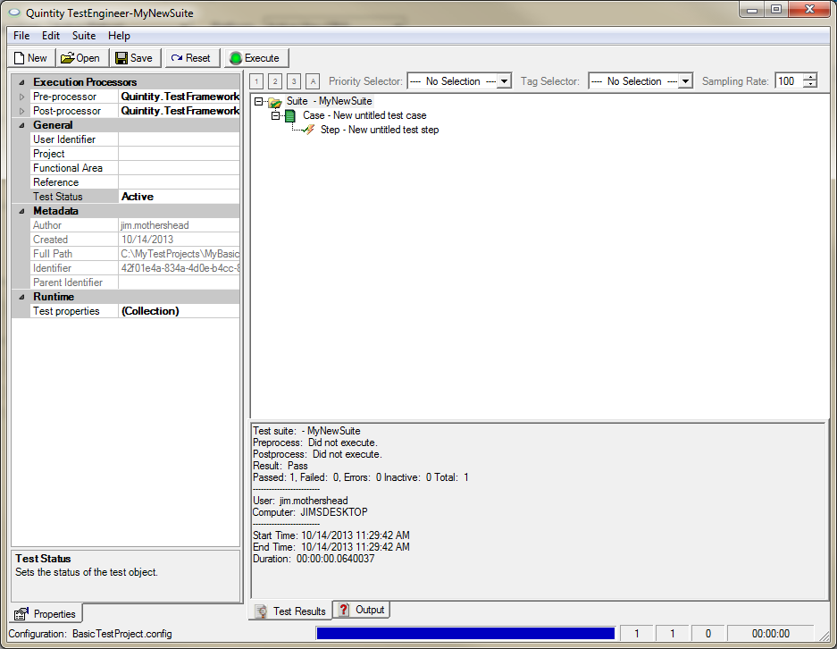

*An example of a successful test run*

## What’s next?

Upon successful completion of the above steps, a fully functional automated test has been created. Clearly the default test method is not a viable test as it does not contain meaningful test logic. This is where the automation engineer and software tester collaborate to define and implement tests specific to their test problem domain.

# Key Concepts

* The Quintity Test Framework – The framework is .NET assembly, Quintity.TestFramework.Core.dll, typically residing in the host’s Global Assembly Cache (the GAC). This core assembly contains a consistent and predictable library of structures and objects representing test concepts (e.g., test suite, test case, test step, test result, etc.) and related components. The framework assembly also contains the Quintity runtime engine which executes test suites and cases and produces results in a reliable manner.
* The Test Project – A Quintity test project is a class library project. A usable test project contains one or more viable test classes containing executable test code. A test project must reference the test framework core assembly (i.e., Quintity.TestFramework.Core.dll).
* The Test Class – A Quintity test class contains one or more compliant Test Methods and is a member of a properly marked-up test project. The class itself must reference the “Quintity.TestFramework.Core” namespace and be derived, directly or indirectly, from the framework’s TestClass object.
* The Test Method – The test method is where the application specific test code is placed. A framework compliant test method is a member of a properly marked-up test class. A test method is a public method which always returns a QTF TestResult value and a TestMethod attribution.

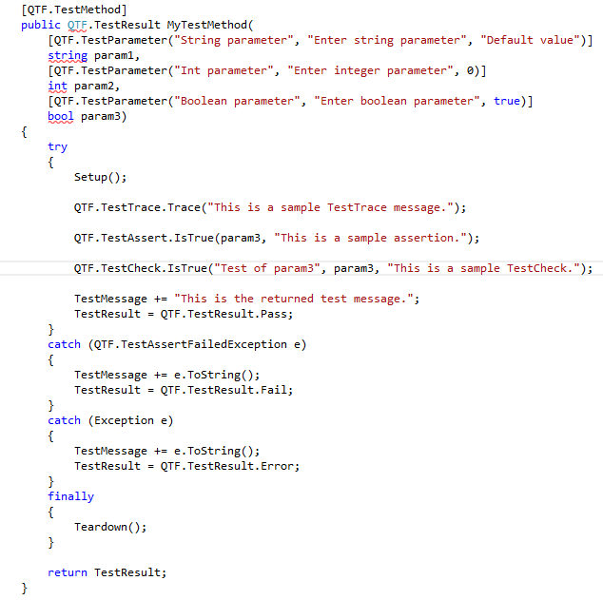*Example of a typical test method*

### Elements of a Test Method

* Setup and Teardown methods – The class virtual methods provide convenient a means of sharing setup routines among test methods. Teardown is the post-execution equivalent. These methods are optional for the test method
* TestResult – Each QTF derived test class has a member property TestResult which is of type TestResult enumeration (i.e., “Pass”, “Fail”, “Error”, “DidNotExecute” or “Unknown”).. A coded test method sets the property or return value which subsequently determines the test step’s test result. Each call to a test method resets the property to its default value of “Pass”.
* TestMessage – In addition to a TestResult value, each test class has TestMessage property. It is a string value that is reset prior to each test method execution. The message is available to return meaningful execution information to the test client (e.g., the TestEngineer).
* TestAssert static methods – The framework contains an Assert class with multiple verification methods to test true/false propositions (e.g., IsTrue, IsFalse, IsNull, etc.). The TestAssert class throws a TestAssertFailedException should the assertion fail.

Example: QTF.TestAssert.IsTrue(param3, "This is a sample assertion.");

* TestCheck static methods – The TestCheck static methods (e.g., IsTrue, IsFalse, IsNull, etc.) provide a means of verifying multiple conditions while continuing to execute the test code (Unlike an TestAssert which can immediately stop execution). TestCheck objects are collected during execution. A single TestCheck failure within the collection will **always** cause the test method to fail regardless of whether the TestResult property is value is proactively set subsequently in the method.

Example: QTF.TestCheck.IsTrue("Test of param3", param3, "This is a sample TestCheck.");

* TestTrace static methods – The class TestTrace contains methods that generate runtime trace information that can be captured by listening clients for further processing.

Example: TestTrace("Connection to web service...");

* + Test Properties – The TestProperties object is a dictionary collection of key/value properties. A property’s value can be accessed at runtime by its unique name (the key). The TestProperties collection is globally accessible; however the scope of any given property is dependent upon where the property is declared. A property can be declared at a number of locations:
* The test configuration file – All properties set in the test configuration are globally accessible during runtime execution of the initial test suite.
* Test suite definition - Properties can be set as part of the test suite definition. These property values are visible to all child test suites and test cases of the suite. Properties set as part of a test suite definition are not visible to parent suites (upon return from child suite execution) or sibling suites.
* Test case definition – Similarly to properties set during test suite definition, properties set during test case definition are visible to all the test case’s child test steps. Upon completion of the test cases execution, the properties are no longer visible to parent test suite or sibling test cases.
* Runtime definition – Properties can also be set at execution runtime. All test classes inherit the base class’s SetProperty method which adds the key/value property pair to the TestProperties collection. The property is only visible to sibling test steps.